## Teacher Side:

[Link](http://course.mobilecsp.org/teach_mobilecsp/unit?unit=2&lesson=55) to Mobile CSP Lesson 2.11 - BB: The Digital Explosion

**BB Reading, Chapter 1:**

* Intro & The Explosion of Bits & Everything Else (pg 1 - 4) and Koan 4 - Processing is Power (Moore’s Law) (pg. 8-9)
* Good and Ill, Promise and Peril (pg. 13 - 16)
* *Note: skips The Koans of Bits (listed below)*

1 - It’s All Just Bits

2 - Perfection Is Normal

3 - There Is Want in the Midst of Plenty

5 - More of the Same Can Be a Whole New Thing

6 - Nothing Goes Away

7 - Bits Move Faster Than Thought

**CSP Framework Alignment**

|  |
| --- |
| **Previous Version** |
| Describe the variety of abstractions used to represent data. [LO 2.1.1]   * EK 2.1.1B At the lowest level, all digital data are represented by bits. * EK 2.1.1C At a higher level, bits are grouped to represent abstractions, including but not limited to numbers, characters, and color. |
| Explain how computing has impacted innovations in other fields. [LO 7.2.1]   * EK 7.2.1F Moore's law has encouraged industries that use computers to effectively plan future research and development based on anticipated increases in computing power. |
| Analyze the beneficial and harmful effects of computing. [LO 7.3.1]   * EK 7.3.1A Innovations enabled by computing raise legal and ethical concerns. * EK 7.3.1H Aggregation of information, such as geolocation, cookies, and browsing history, raises privacy and security concerns. * EK 7.3.1J Technology enables the collection, use, and exploitation of information about, by, and for individuals, groups, and institutions. |

## Lesson Activities (90 minutes):

On the first day, they’re introduced to the topic, do the first reading, and learn about the journaling assignment. On the second day, they compile the class journal results, do the second reading, and discuss the positive/negative implications of the technology they journaled.

**Day 1:**

* ***Hook/Motivation (10 minutes):***
  + Ask the students to look around their classroom and identify things that process digital data, or bits. This might include: computers, calculators, light switches (with sensors), smart boards, projectors, phones/tablets, etc. Keep a running list on the board for them to see.
  + Explain to students that Chapter 1 of Blown to Bits makes the point that today everything is digital -- that is, everything is represented by binary digits or bits. And it provides some provocative examples of the societal implications of this digital explosion.
  + *[Deleted - Data Powers of 10, but could bring back if enough time?]*
* ***Experiences and Explorations (25 minutes):***
  + Introduce the textbook to the students and give them the Double Entry Journal Template to record their thoughts. Students should read pg. 1-4 in Chapter 1 of Blown to Bits and Koan 4.
  + In small groups of 3-4 students, discuss the reading. Have each student share at least one of their quotes from the reading.
  + Ask each group to share one idea from their discussion with the whole class.
* ***Rethink, Reflect, and Revise (10 minutes):*** 
  + Introduce the journal assignment and hand out the tracking template. (See directions on student side)
  + Ask students to make predictions of how many different objects they will interact with that process digital data, or bits.

**Day 2:**

* ***Hook/Motivation (15 minutes):***
  + Have students share the types of objects and the number of times they used them using some kind of data tracking (board, spreadsheet, etc.) - can they be organized into categories or types of some kind?
  + How do these compare to their predictions?
* ***Experiences and Explorations (20 minutes):***
  + Ask students if there are both positive and negative impacts from the technology they used? Ask them if they believe that the technology itself is good or bad?  
    *They will likely identify positive impacts and may have difficulty with negative impacts. The discussion after the reading should help them to better identify negative impacts of using technology.*
  + Students should read the second part of Chapter 1, Good and Ill, Promise and Peril (pg. 13-16). (This could also be assigned to read outside of class.)
  + Students should get into groups of 4, then use the [Debate Team Carousel](https://docs.google.com/document/d/1g5fuVEDu3V2XHVRBok1gFAOaAV7eWyict1S2ROopsw0) handout with one of the following questions/topics:
    - Select topics based on the list of current events articles at TeachGlobalImpact.org. Each group can have the same or a different topic.
    - Examples of Questions:
      * Should voting be electronic?
      * Should apps be used to help track and diagnose mental health?
      * Should digital assistants (such as Alexa) talk like humans?
* ***Rethink, Reflect, and Revise (10 minutes):*** 
  + Pick a current real-world example that students can explore. (Examples might be Google Glass, Apple Watch, FitBits) Students should describe what the product/initiative is and also discuss its positive and negative implications on life in the Digital Age. Students will need to find a similar example for their portfolio reflection.

## Student Side:

[Link](https://mobilecsp-2017.appspot.com/mobilecsp/unit?unit=1&lesson=62) - Note: must be registered for the course in order to see this Lesson.

# **BB: The Digital Explosion**

# **Time Estimate: 90 minutes**

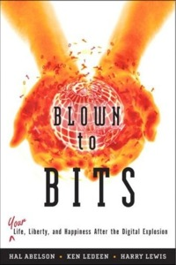

Computing has transformed our lives in so many ways. And mobile computing, where we are constantly connected to others and to the world via our mobile devices, is challenging us right now to come with new norms about privacy, security, the ownership or openness of data and information, and other issues.

Like any technology, mobile computing has both positive and negative impacts. We need to reflect on these impacts in general and we also think about the impacts we will create as we build our own mobile apps.

## 

## **Chapter One: The Digital Explosion—Why Is It Happening and What Is At Stake?**

[Chapter One of Blown to Bits](http://www.bitsbook.com/wp-content/uploads/2008/12/B2B_3.pdf#page=19) makes the point that today everything is digital -- that is, everything is represented by binary digits or bits. And it provides some provocative examples of the societal implications of this digital explosion.

Take a look around your classroom or room. Where can you see devices that use bits? Try to think beyond just your computers and mobile phones or tablets. For example, is the room's light switch on a timer or have a motion sensor? Here are [some examples](https://docs.google.com/presentation/d/1rY94EKJPiqiGXd3XR2KIw8dSkz3psOFNADcI0JSR1wU) you can use to help you get started.

## **Activities**

**Part 1:** Read pages 1-4 in Chapter One and Koan 4 about Moore's Law on pages 8-9 to learn more about how quickly our world has become digital. As you read, use the [Double Entry Journal](https://docs.google.com/document/d/1zJ__6P0CvtL2CGAFzHF7T4tc6hRAkmhZPvGu7gdl_4o/edit) (File -- Make a copy for an editable version) to summarize and comment on at least four quotes or summarized ideas that the authors bring forward in this chapter. Discuss your quotes with your classmates. Below is an image that represents Moore's Law graphically - the observation that the number of transistors per square inch on integrated circuits had doubled every two year since their invention. This the speed at which we can process digital data increases exponentially every year.

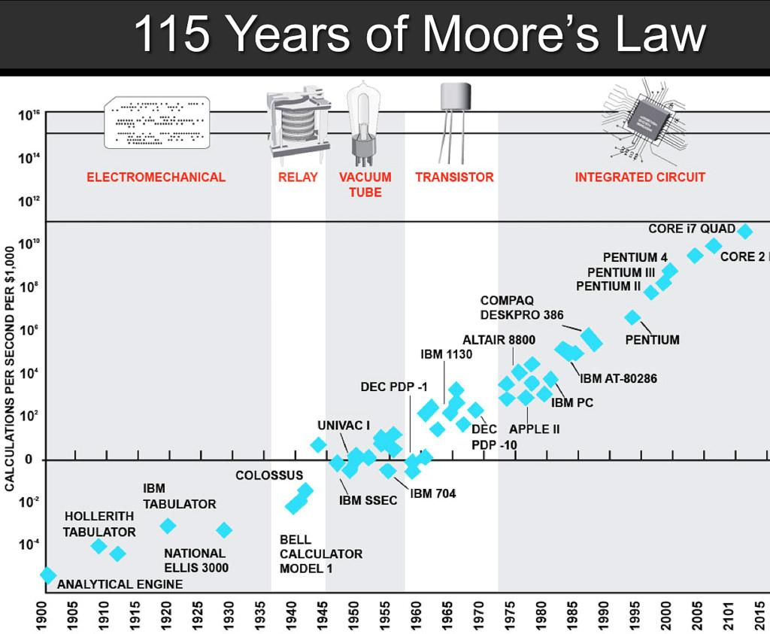

**Part 2:** Over the next 24 hours, keep track of all the technology that you use. For example, do you use your phone to set an alarm? Does your coffee maker include a mini-computer? Keep a running list of items that you use and then make a tally or count how often you use them during the day. Once you're done, consider how easy or difficult would it be to make it through a single day without using a computer. Which of your daily activities could you do without digital information or devices?

**Part 3:** Read pages 13-16 (Good and Ill, Promise and Peril) in Chapter One which takes a look at the positive and negative implications of the digital explosion. This is an important concept and one of the key components of the Explore Performance Task for the AP exam. Get into groups of 4 and use the [Debate Team Carousel](https://docs.google.com/document/d/1g5fuVEDu3V2XHVRBok1gFAOaAV7eWyict1S2ROopsw0) handout to discuss this concept further.

## **Still Curious?**

Check out some current events about the positive and negative impacts of technology in [these articles](http://teachglobalimpact.org/main/forums/topic-tag/7-3-1-benefits-and-harm/)

## **Self-Check**

Here is a table of the technical terms introduced in this lesson. Hover over the terms to review the definitions.

|  |  |
| --- | --- |
| bit  byte  blacklist  character  data  data center  data network | disk drive  intellectual property  Moore’s Law  network  processor  social network  whitelist |

## **Homework: For Your Portfolio**

Create a page called ***Blown to Bits Chapter 1*** under the *Homework* category of your Portfolio (If you are using the Mobile CSP Student portfolio template, this page has already been created for you) and post brief answers using complete sentences to the following questions on that page.

1. What is a *bit* and what does it mean to say that "it's all just bits"? (Koan 1) Give examples of the things today that are stored in bits?
2. Describe, in your own words, Moore's Law.
3. Give an example of how the digital explosion is "neither good nor bad" but has both positive and negative implications.
4. Find and summarize a news article that talks about the positive or negative impacts of a computing innovation. Is the technology itself positive or negative? Or have people used the technology in positive and/or negative ways?